Adnan Aygunduz  
Capstone #1 Project Report  
Springboard DS, March 2019

**Can Air Accidents and Incidents Be Predicted?**

**Problem:** Air accidents and incidents can cost lives and huge resources. Understanding the factors behind them based on the previous data we have can help authorities to take preventative measures in advance and save lives and valuable assets. Thus, this project will answer the question if we can create algorithms in order to predict before it happens or not based on the collection of data we have so far. Since air transportation safety and specifically flight safety is the paramount, government organizations such as National Transportation Safety Board (NTSB) and commercial air carriers will benefit from the outcomes of this study.

**Data:** The NTSB aviation accident database contains information from 1962 and later about civil aviation accidents and selected incidents within the United States, its territories and possessions, and in international waters. Generally, a preliminary report is available online within a few days of an accident. Factual information is added when available, and when the investigation is completed, the preliminary report is replaced with a final description of the accident and its probable cause. Full narrative descriptions may not be available for dates before 1993, cases under revision, or where NTSB did not have primary investigative responsibility.

**Data Set:** [ntsb-aviation-accident-dataset](https://public.opendatasoft.com/explore/dataset/ntsb-aviation-accident-dataset/information/?dataChart=eyJxdWVyaWVzIjpbeyJjaGFydHMiOlt7InR5cGUiOiJsaW5lIiwiZnVuYyI6IkNPVU5UIiwic2NpZW50aWZpY0Rpc3BsYXkiOnRydWUsImNvbG9yIjoiI0QwNTM1NiJ9XSwieEF4aXMiOiJldmVudF9kYX)

**Data Wrangling:**

1. **What kind of cleaning steps did you perform?**

###### After Prioritizing the Data Fields I followed the basic steps below as a checklist to clean my data set.I mainly used pandas. Before I got started I ran some commands such as "head()", "info()", "describe()", "pandas_profiling.ProfileReport()" and "isna().any()" to better understand the dataset that I am dealing with.

1. Cleaning Duplicates

With this command I got rid of all repeated rows in my dataset

df.drop_duplicates(subset=None, keep='False', inplace=False)

1. Cleaning White Spaces

To get rid of seen or unseen extra spaces (white spaces) I've applied

df.column_name.apply(lambda x: x.strip())

1. Standardize existing columns and create new ones

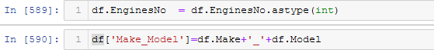

1. Change Text to Lower/Upper/Proper Case.

.apply(lambda x :x.replace('-','_')



1. **How did you deal with missing values, if any?**

First I found out the total missing values and their percentage to the data frame.

mis_val = df.isnull().sum()

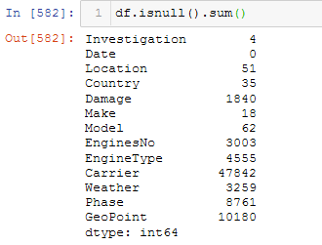

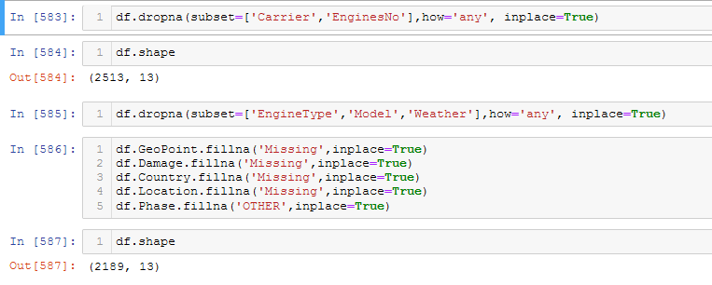

mis_val_percent = 100 * df.isnull().sum() / len(df)

#### For missing categorical data simply labeled them as ’Missing’, Other or 'N/A' !

For missing numeric data, first flagged them as missing and then filled them according to data content, sometimes with '0's and sometimes with mean and sometimes with ffill() methods.

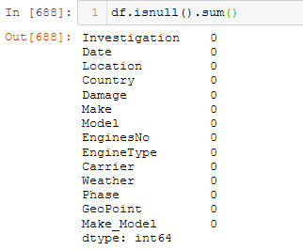

1. **Were there outliers, and how did you handle them?**

There were minor outliers in my data set since it's consisting of mostly categorical data. With those minor outliers I applied 'numpy.std ' standard deviation method to highlight any points above (Mean + 2*SD) and any points below (Mean - 2*SD).

**Initial Findings**

Almost all columns were containing white spaces, different representations of same data such as combinations of lower and upper cases and additional punctuation marks etc. Therefore Regrex method used for cleaning and regrouping same data.

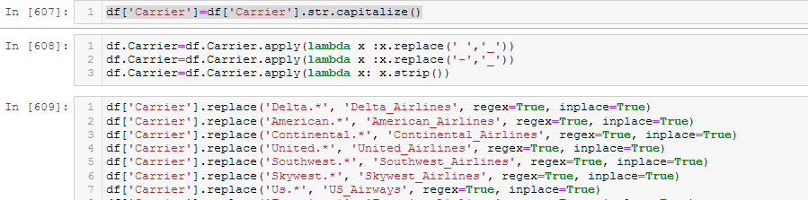

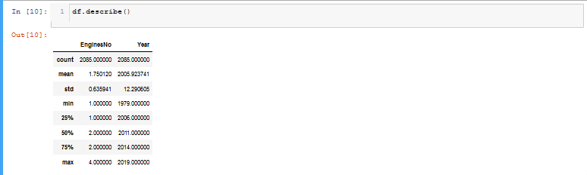

This data set is consisting of all categorical data except the 'EngineNo' number of engines column. Therefore analyses are based on bar charts created from value counts.

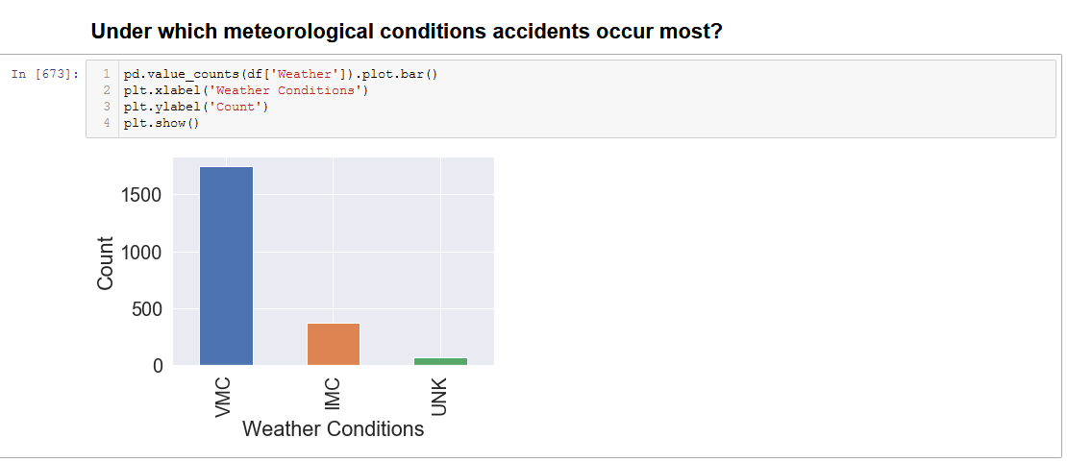

Accidents occurred in Visual Meteorological Conditions more than the Instrument Meteorological Conditions. IFR flights relies on aircraft instruments. In VMC, visual references are used as primary data. Technological developments in aviation instruments can affect the accuracy of the flight under IFR conditions.

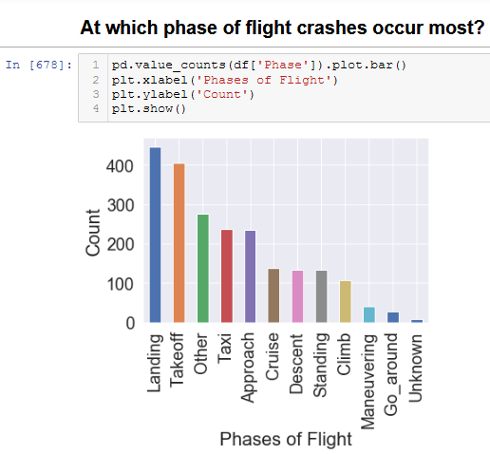

Based on the chart above landing and take-off phases of a flight are the most critical time frames.

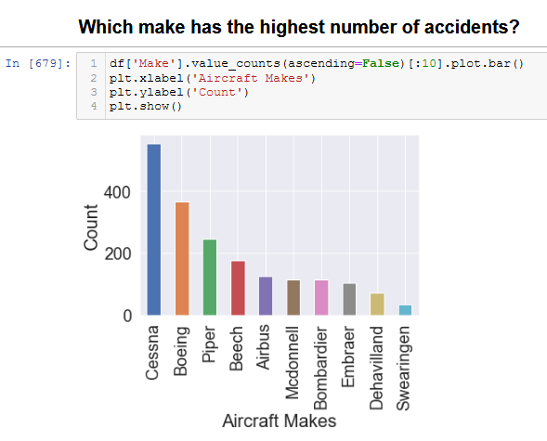

To be able to make a sound judgment total flights hours of each make should also be taken into consideration.

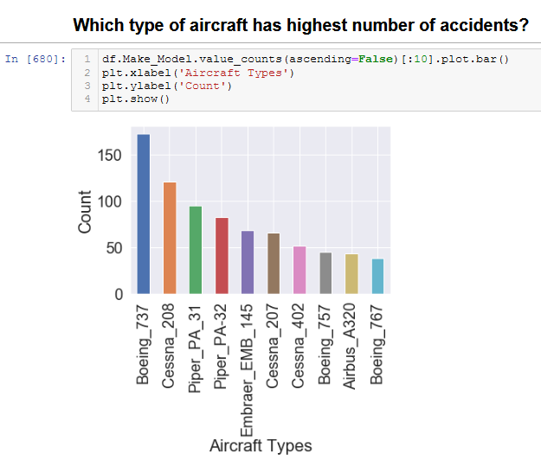

Time distribution should be observed between each accident of a same make and model.

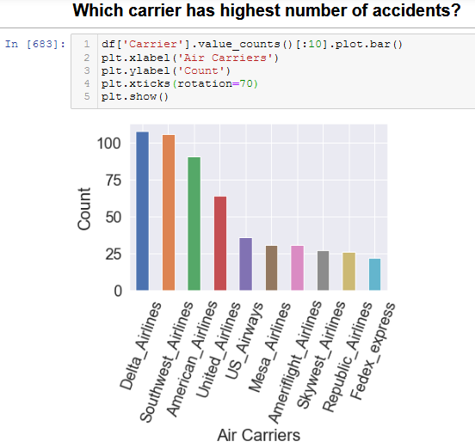

To be able to make a sound judgment total flights hours of each carrier should be taken into consideration.

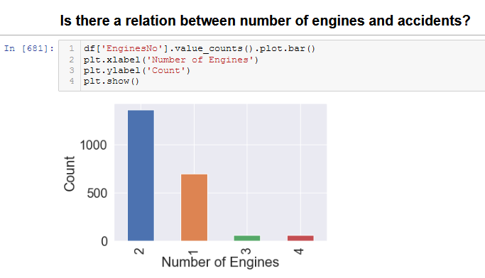

Majority of the aircrafts involved in an accident were twin engine. Total flight hours should also be considered.

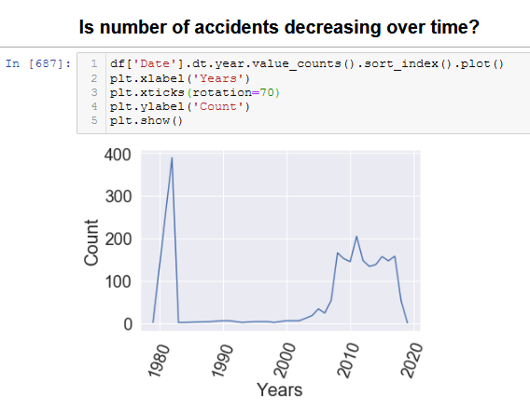

Decreased number of accident between 1982 and 2004 might be the result of applied new practices after huge number of accidents.

**The Null and Alternate Hypothesis**

H0:There is no statistically significant relationship between weather conditions and investigation type.

Ha:There is a statistically significant relationship between weather conditions and investigation type.

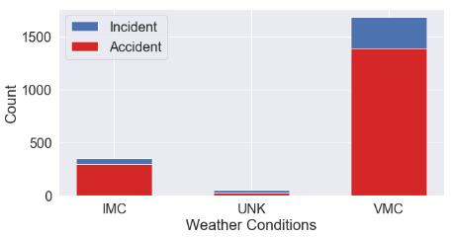

**The Chi-Squared Test for Independence - Calculation with Numpy**

In order to determine whether we accept or reject the null hypothesis. We have to compute p-value similar to the welch's t-test and ANOVA. For testing with two categorical variables, we will use the Chi-squared test.

X2=(observed−expected)**2 / (expected)

First, let's put the observed values into a one dimensional array, reading the contingency table from left to right then top to bottom.



Next, we need to calculate the expected values. The expected values assume that null hypothesis is true. We would need to calculate values if there is an equal percentage of accidents and incidents for each category. For example, this is how we would calculate the expected value for the top left cell:

Expected # of Accidents in the VFR category = Total # of Accidents ∗ Number of Investigations in the VFR / total # of Investigations.

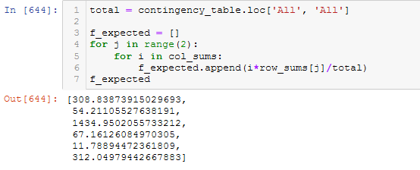

Now that we have all our observed and expected values, we can just plug everything into the Chi-squared test formula.

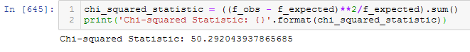

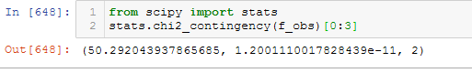

Now we are ready to look into the Chi-squared distribution table. Our x2 statistic was so large that the p-value is approximately zero. So we have evidence against the null hypothesis.

The results were exactly the same as our calculations with Numpy.

The X**2 = ~49, p-value = ~0 and degrees of freedom = 2.

Conclusions

With a p-value < 0.05 , we can reject the null hypothesis. There is definitely some sort of relationship between Accident and the Incident column. We don't know what this relationship is, but we do know that these two variables are not independent of each other.

**Machine Learning**

Since all the data in this dataset was categorical, we had to first deal with converting them into numerical data before moving on with the classification algorithms.

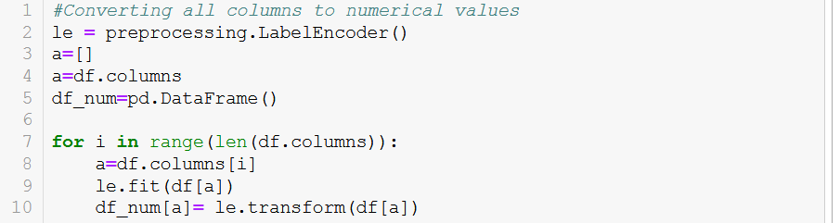

LabelEncoder method was used for this purpose.

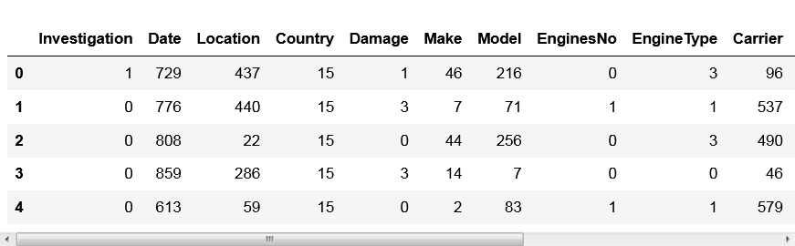

After conversion is done, Logistic Regression was applied to new numerical dataset (df_num).

Logistic Regression

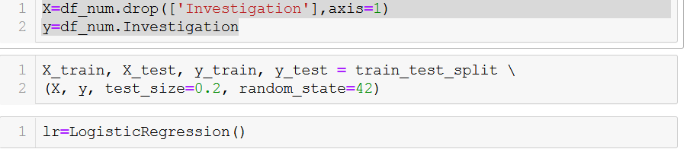



'Investigation' feature which consists of 'Accident' and 'Incident' variables selected as Target data (y). Then Test and Train data split by 20/80.

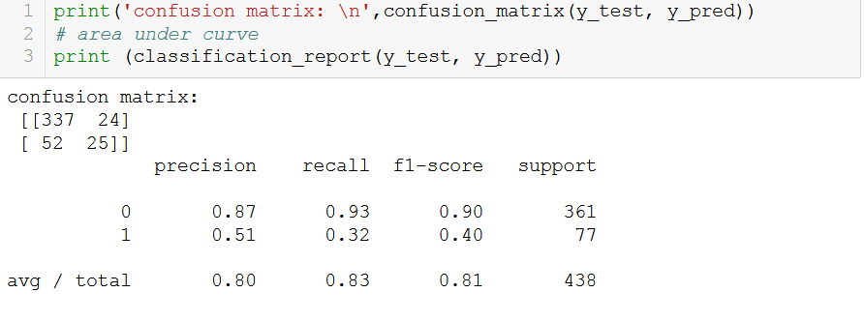

Based on the confusion matrix values we can say our model successfully predicted Accidents and Incidents. That means that all the features we used to predict Investigation Type variable have a direct relationship. Currently this model is not capable of predicting possible future air accidents yet. However if this dataset can be enriched with some more data such as total flight hours of each aircraft model, engine, and pilots during the accident in addition to annual and total flight hours of each air carrier a sound risk analyses can be done.